Project III

1. Objective
Build the network in Cisco Packet Tracer (2 switches, 1 router, 4 end devices), configure basic IP addressing, and verify end-to-end connectivity.

2. Simple Diagram
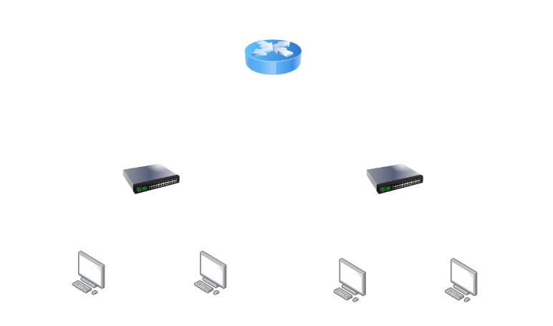

7. OSI Layer Explanation & Mapping

I created a small network in Cisco Packet Tracer using one router, two switches, and four PCs. The router is used to connect two different networks: 192.168.10.0/24 and 192.168.20.0/24. PC1 and PC2 are connected to Switch 1, while PC3 and PC4 are connected to Switch 2. I assigned a separate IP address, subnet mask, and default gateway to each PC.
The router has two interfaces, 192.168.10.1 and 192.168.20.1. These interfaces allow devices in the two networks to communicate with each other. The switches are mainly used to connect the PCs and forward the data to the correct device using their MAC addresses.
I also related the configuration to the OSI model. The Ethernet cables represent Layer 1 (Physical Layer), and the switches mainly work at Layer 2 (Data Link Layer). The IP addresses, subnet masks, default gateways, and routing are part of Layer 3 (Network Layer). Finally, I used the ping command to check whether the devices could communicate. The successful ping between PCs on different networks showed that the router was correctly connecting the two networks.

Device | OSI Layer | Role
Router | Layer 3 – Network Layer | Connects the two networks and forwards packets
Switch 1 | Layer 2 – Data Link Layer | Connects PC 1 and PC 2
Switch 2 | Layer 2 – Data Link Layer | Connects PC 3 and PC 4
PC 1 | Layer 7 – Application Layer | End-user computer
PC 2 | Layer 7 – Application Layer | End-user computer
PC 3 | Layer 7 – Application Layer | End-user computer
PC 4 | Layer 7 – Application Layer | End-user computer

3. Build the Topology in Packet Tracer
- Place one router (for example, Cisco 1941/2911), two 2960 switches, and four PCs.
- Connect R1 G0/0 to SW1 using a Copper Straight-Through cable.
- Connect R1 G0/1 to SW2 using a Copper Straight-Through cable.
- Connect PC1 and PC2 to SW1; connect PC3 and PC4 to SW2.
- Wait for the links to become green before testing connectivity.

4. Configure Router R1
Open R1 → CLI and enter:
enable
configure terminal
interface gigabitEthernet 0/0
ip address 192.168.10.1 255.255.255.0
no shutdown
exit
interface gigabitEthernet 0/1
ip address 192.168.20.1 255.255.255.0
no shutdown
exit
end
show ip interface brief
The two networks are directly connected to R1, so no static route is required for this topology.

5. Configure PC IPv4 Settings
For each PC: Desktop → IP Configuration → select Static and enter the values below.
- PC1: IP 192.168.10.10 | Mask 255.255.255.0 | Gateway 192.168.10.1
- PC2: IP 192.168.10.11 | Mask 255.255.255.0 | Gateway 192.168.10.1
- PC3: IP 192.168.20.10 | Mask 255.255.255.0 | Gateway 192.168.20.1
- PC4: IP 192.168.20.11 | Mask 255.255.255.0 | Gateway 192.168.20.1

6. Verify End-to-End Connectivity
From PC1 → Desktop → Command Prompt, run:
ping 192.168.10.11
ping 192.168.20.10
ping 192.168.20.11
Successful replies from PC2, PC3, and PC4 demonstrate local-switch and routed communication. You can also test the gateways with ping 192.168.10.1 and ping 192.168.20.1.
Optional path verification from a PC: tracert 192.168.20.10

